Document Number | RP6
Document Title | Sending results
Department Ownership | Reception
Document Type | Procedure
Department Owner | Alysia Harper and Angela Di Pardo
Document Author | Angela Di Pardo
Last Edited By | Derrick Chan | Lasted Edited On | 07/04/2015

Purpose

This Procedure outlines the process that needs to be followed to send medical results to the appropriate company/person.

Scope

For all staff at the Health screenings reception

Reference Documents

Definitions

Flowcharts (Other Images)

Procedures

Once a pre-employment has taken place and the patient has seen both the exercise physiologist and the doctor the file must then be placed in the awaiting results tray on receptions desk.

Once we receive the drug and alcohol results from western diagnostics we can then send the completed file to the company.

- Order the results into the appropriate scanning order (follow scanning procedure)

- Scan the results into the system so that they can be sent electronically via email. (follow scanning procedure)

- Once the file has been scanned into the computer system open a new email message by selecting “new email” and a window will appear as below.

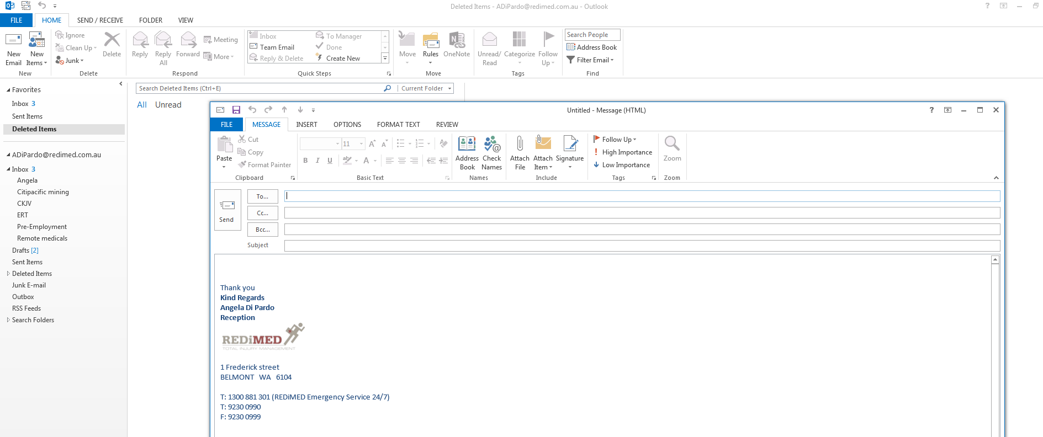

- If you consult the booking form it should notify you on whom the results need to be sent to. If there is nothing that will indicate this on the booking form search your email as well as other reception staff to see if they can find out who sent through the booking form.

- Once you have discovered whom you are going to send the results to simply type the address in the “TO” bar and type the patients name in the Subject field as below.
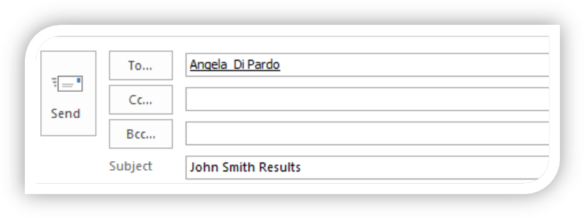

- In the email field type a short sentence as below and sign off with your email signature.
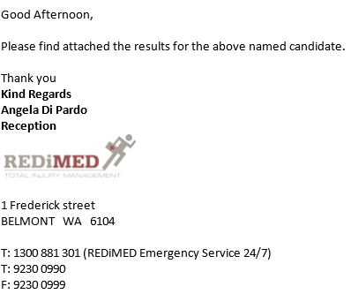


- Attach the results to the email by selecting “attach file”

- The below window will appear. Select the scanned documents drive (S:/drive) and search for the patient’s name.

- Once you locate the name, select the file and then “open”. This will insert the file into the email and it can now be sent.
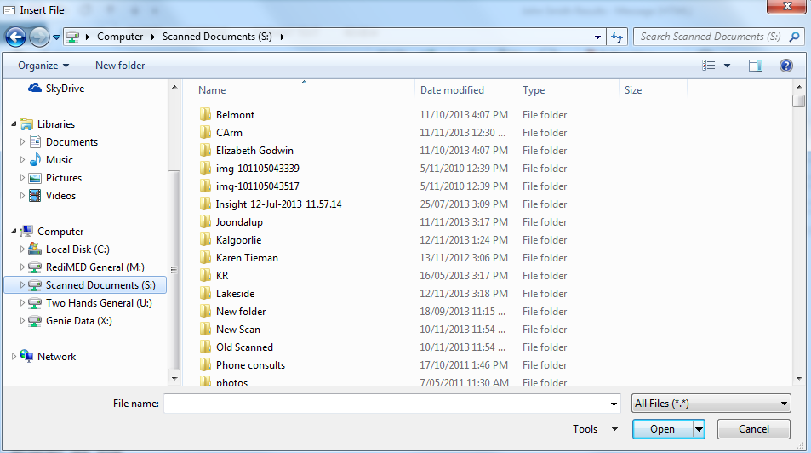

- The final steps of sending results is checking that the patient has been billed and that the results have been linked into the patients file in Genie. (follow linking and billing procedure if not Billed or linked)

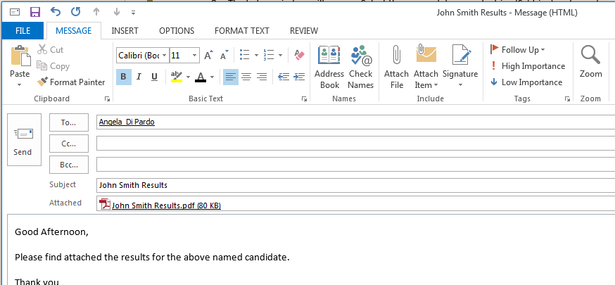

Appendices

